**International Debt Statistics Analysis**

* **Countries**

1. Top 10 Countries with Highest Debt

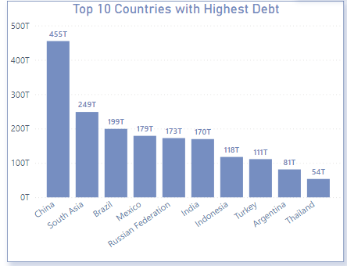

1. Top 10 Countries with Lowest Debt

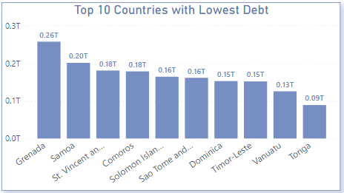

1. Debit by Countries in Coming Years

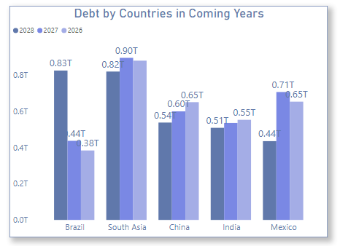

1. Counties with Highest and lowest Debt

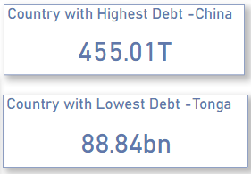

* **Debt Indicators or Segment**

1. Top 5 indicators

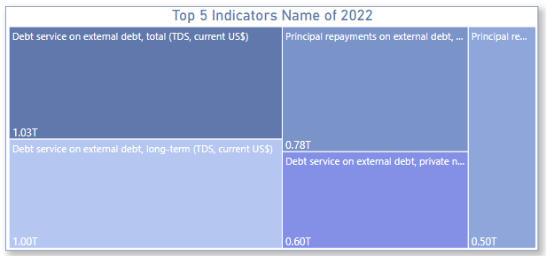

1. Debt by Indicators

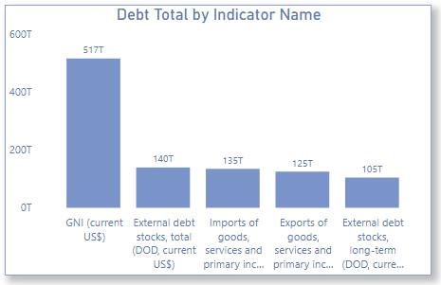

1. Average Debt by indicators

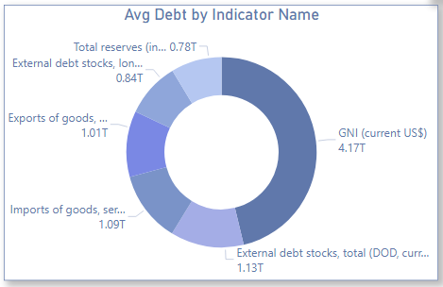

1. Highest and lowest indicators

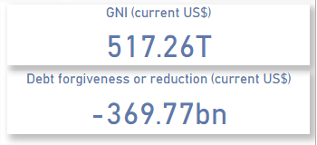

# Insights

1. There are **124 countries** which have **debt from World Bank**.
2. The **Total Debt** by all **countries is 2.69E + 15**.
3. There **different 569 debt indicators** which the
4. The **country** with **highest debt is China with 455.01T**.
5. The **top 10 countries with highest debt** are **China, South Asia, Brazil, Mexico, Russian Federation, India, Indonesia, Turkey, Argentina and Thailand.**
6. The **country** with **lowest debt is Tonga with 88.84bn**.
7. The **top 10 countries with lowest debt** are **Grenada, Samoa, St. Vincent and the Grenadines, Comoros, Solomon Islands, Sao Tome and Principe, Dominica, Timor-Leste, Vanuatu, and Tonga.**
8. Top one debt indicator **GNI (Current US$)** and least one debt indicator is **Debt forgiveness or reduction (Current US$).**
9. **5 Debt by indicators are** GNI (Current US$)**,** External Debt stock, total (DOD, current US$)**,** Imports of goods and services and primary income**,** Exports of goods and services and primary income**,** External Debt stock, long term(DOD, current US$)
10. **Top 5 debt indicators in 2022 are**

* Debt service or External, total (TDS, current US$)
* Principal repayments on external debt, long term(AMT, current US$)
* Debt service or External, long term (TDS, current US$)
* Debt service or External, private nonguaranteed PNG(TDS, current US$)
* Principal repayments on external debt, private nonguaranteed (PNG)(AMT, current US$).

1. **Average 5 indictors are**

* GNI (Current US$)
* External Debt stock, total (DOD, current US$)
* Imports of goods and services and primary income
* Exports of goods and services and primary income
* External Debt stock, long term(DOD, current US$)